Market Monitor - Afghanistan - 2026-06

Highlights
In June 2026, the cost of essential food items in Afghanistan saw a month-on-month decrease, offering short-term relief to consumers. However, prices remain elevated compared to the previous year, indicating persistent underlying inflation.
The national average cost of the standard food basket decreased by 1.5% in June to AFN 554.86. Despite this monthly drop, the basket is 6.2% more expensive than in June 2025.
The monthly price reduction was led by significant drops in the cost of Sugar (↓5.0%), Wheat (↓4.0%), and high-quality Rice (↓3.2%).
Key Market Drivers:
- Falling Staple Prices: A broad decrease in the prices of essential food commodities, particularly sugar and cereals, was the primary driver of the food basket's lower cost this month.
- Currency Stability: The Afghani (AFN) remained stable, appreciating slightly against the US dollar (↓1.4% MoM). This helped to contain the cost of imported goods and contributed to overall price moderation.
- Persistent Annual Inflation: Despite the monthly relief, significant year-on-year price increases for key items like high-quality Rice (↑31.2%) and Sugar (↑21.9%) continue to strain household budgets and highlight long-term inflationary pressures.
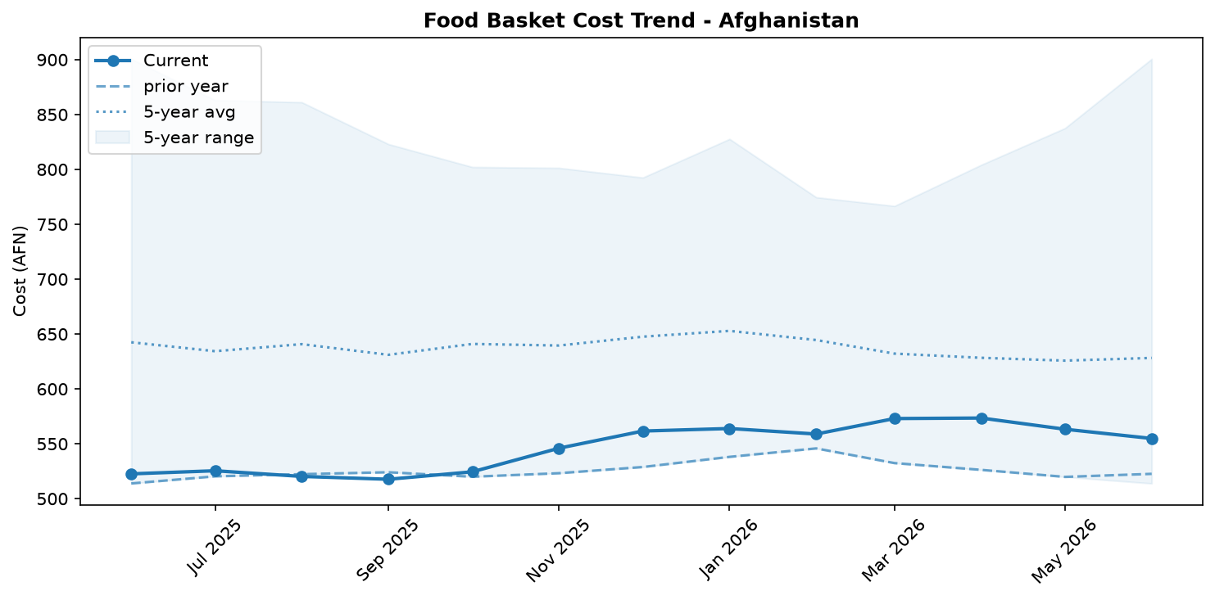
Food basket cost trend

Market Overview
Market conditions in June 2026 offered short-term relief to Afghan consumers, as the price of the standard food basket decreased by 1.5 percent month-on-month. This downward trend was primarily driven by a broad-based fall in the prices of essential commodities, including sugar (-5.0%), wheat (-4.0%), and rice (-3.2%), reflecting adequate supply from ongoing domestic harvests. The continued strength of the Afghani, which appreciated 1.42 percent against the US dollar, also helped to moderate the cost of imported goods. However, this positive development is tempered by significant underlying inflationary pressures. The food basket remains 6.2 percent more expensive than in June 2025, highlighting persistent year-on-year inflation. Furthermore, a 2.1 percent monthly increase in the price of diesel, linked to regional supply chain disruptions and border closures with Pakistan, is creating upward pressure on transportation and production costs. This poses a considerable risk to the current price stability, threatening to erode recent gains in food affordability for vulnerable households. The overall market situation remains fragile, with seasonal improvements competing against structural logistical and economic challenges.

Commodity Analysis
In June, most food commodities saw price decreases, providing a respite for households. The prices of staple cereals fell, with wheat declining by 4.0 percent and high-quality rice by 3.2 percent, largely due to improved availability from the current harvest season. Sugar recorded the most significant monthly drop at 5.0 percent. However, the year-on-year perspective reveals a more challenging reality: rice and sugar prices are 31.2 percent and 21.9 percent higher, respectively, than in June 2025, indicating severe long-term price inflation and volatility. Pulses were a notable exception to this long-term trend, with prices falling 1.3 percent month-on-month and a significant 12.3 percent year-on-year, suggesting a sustained supply recovery. In contrast, salt was the only food item to register a price increase, rising 1.5 percent month-on-month and 9.8 percent year-on-year. Outside the food basket, the rising cost of fuel is a major concern. Diesel prices increased by 2.1 percent month-on-month, driven by logistical disruptions. This directly increases transportation and agricultural input costs, creating a significant risk of future price hikes for food and other essential goods, potentially reversing the recent downward trend.
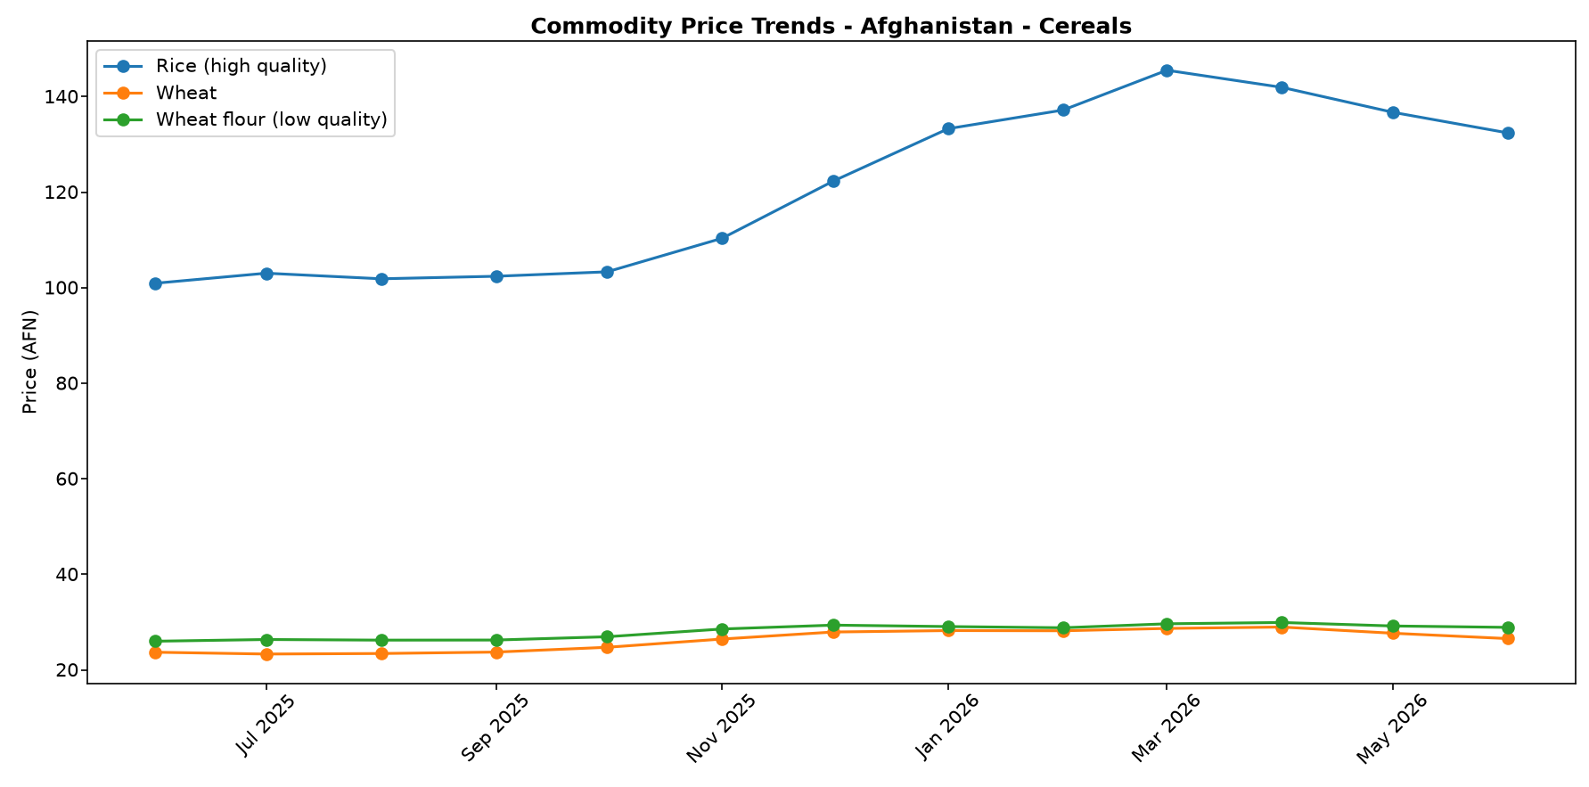
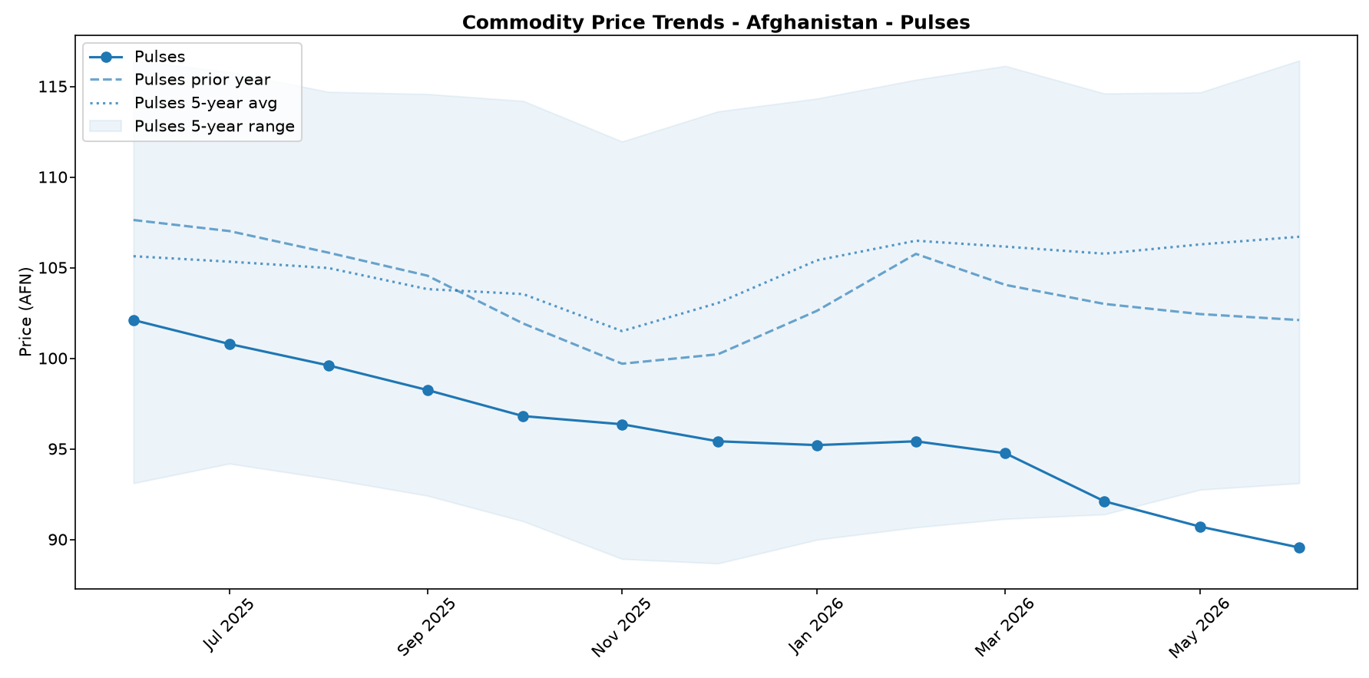
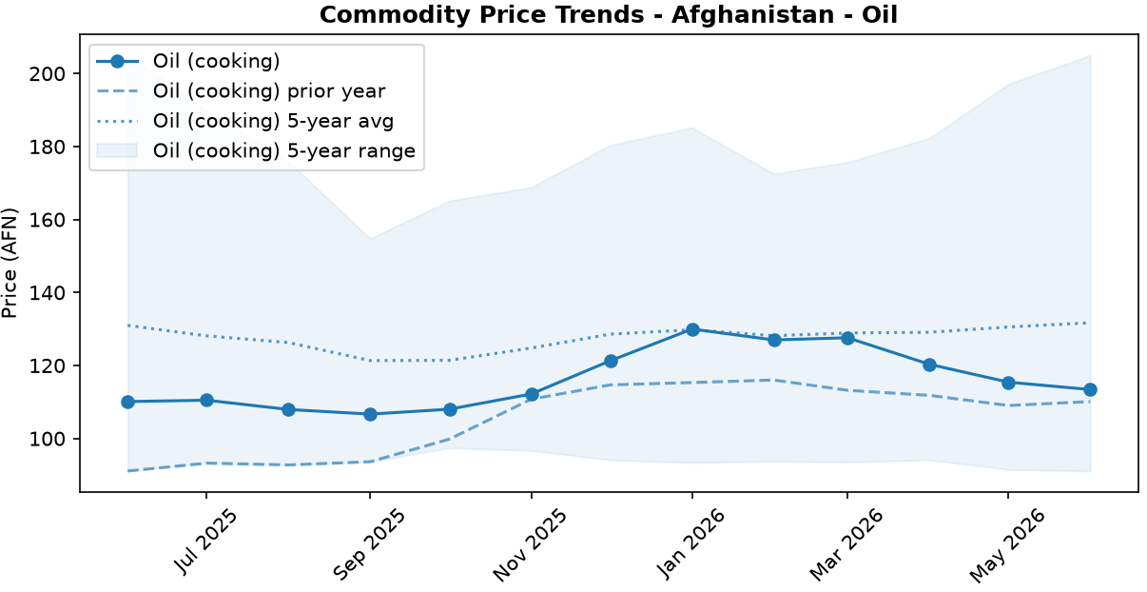
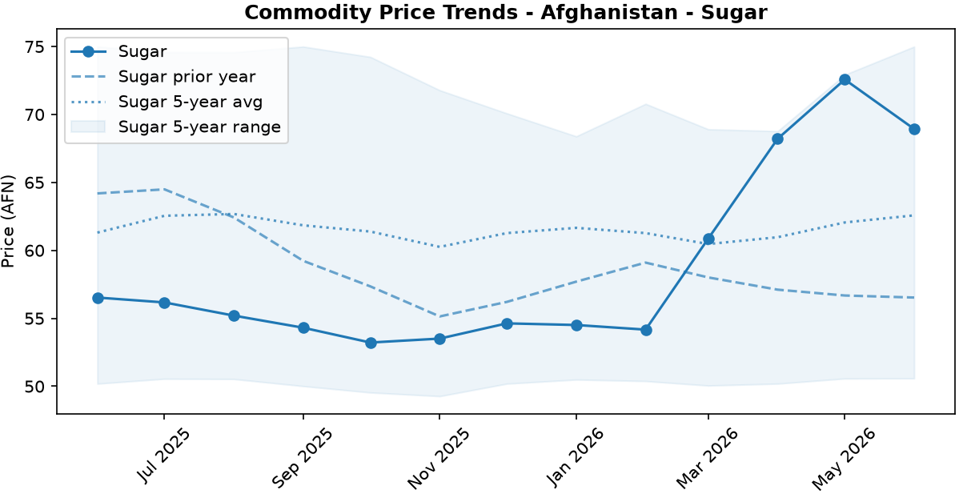
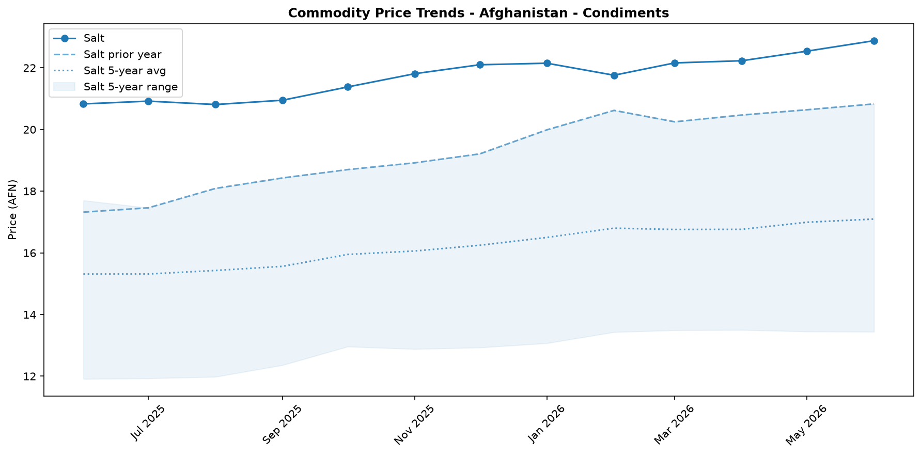

Regional Highlights
National price averages conceal significant economic disparities across Afghanistan, particularly in the fuel sector. The retail price of diesel exhibits a stark regional variation, with a 25.9 percent price gap between the lowest price in Nimroz (AFN 58.0/Litre) and the highest in Nuristan (AFN 73.0/Litre). This wide spread underscores the impact of inconsistent supply chains and logistical bottlenecks across the country.
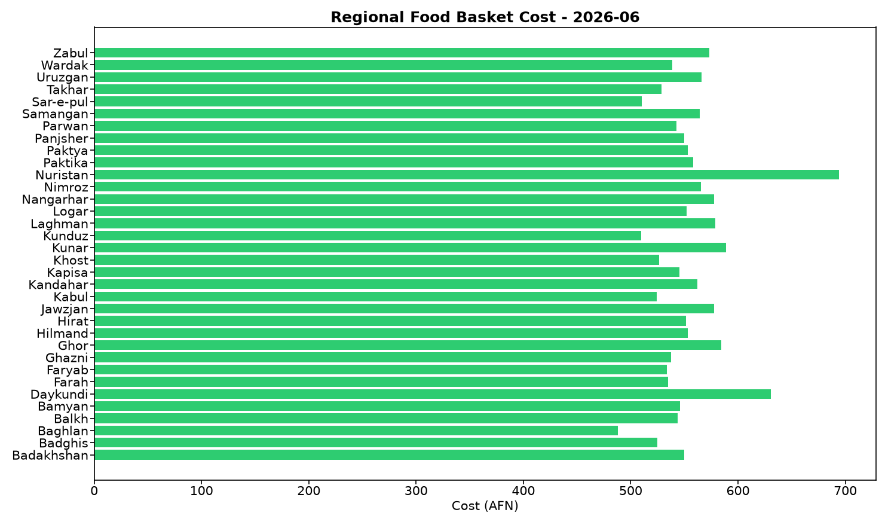
The higher prices in eastern provinces like Nuristan are likely linked to persistent cross-border tensions and trade disruptions with Pakistan. Conversely, the lower prices in western provinces such as Nimroz may reflect the strategic shift of trade volumes through Iranian corridors, which, while reportedly more expensive overall, appear to be providing a more stable supply to adjacent regions. These localized price pressures directly affect the cost of living and doing business, with communities in poorly connected or border-adjacent regions facing disproportionately higher costs for transportation, agricultural production, and, ultimately, staple goods.

Fuel & Energy
The national average retail price of diesel increased by 2.1 percent to AFN 65.44 per litre in June 2026, standing 4.4 percent higher than the same period last year. This price rise is consistent with supply and logistical pressures affecting the domestic fuel market. Higher fuel costs exert upward pressure on transportation expenses, which risks increasing the final market price of staple foods and eroding the purchasing power of households, despite recent decreases in some food commodity prices. Significant regional price variations persist, with prices in Nuristan over 25 percent higher than in Nimroz, reflecting inconsistent supply across the country.
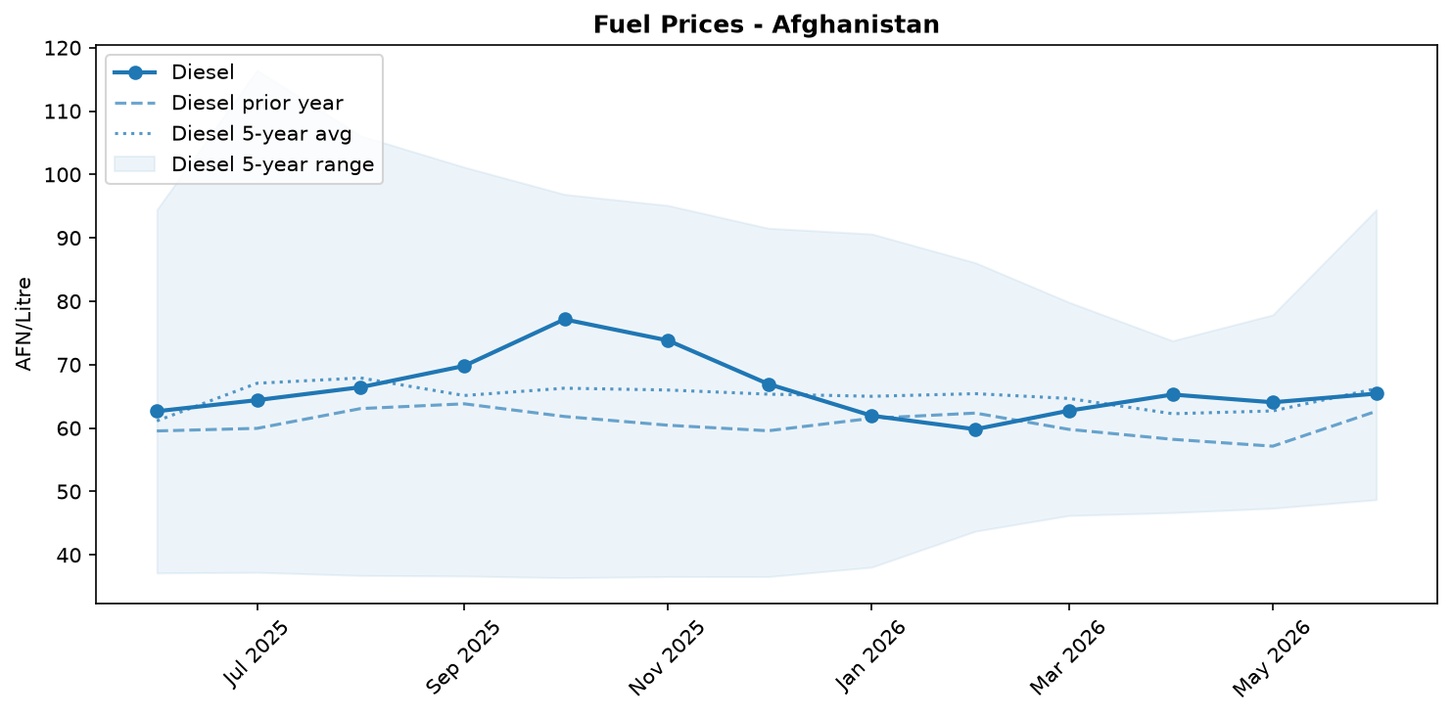
Fuel retail price trend

Exchange Rate Analysis
The Afghan Afghani (AFN) continued its appreciation trend, reaching 63.0 AFN per USD. Month-on-month, the currency strengthened by 1.42 percent, which helps to lower the cost of imported goods. This recent gain is part of a longer-term trajectory, with the AFN appreciating by a significant 10.27 percent year-on-year. The sustained strengthening of the currency is a positive development for food security in a country reliant on imports. A stronger AFN reduces the local currency cost of essential commodities such as wheat, rice, cooking oil, and fuel. This can help stabilize domestic food prices and support the purchasing power of vulnerable households, potentially improving their access to a nutritious diet.

References
- [rw_4218118] ReliefWeb (2026-06-26) Food security under pressure: Impacts of the Middle East Crisis and Pakistan Conflict on Afghanistan (June 2026)
https://reliefweb.int/node/4218118
- [rw_4218068] ReliefWeb (2026-06-26) Afghanistan: Countrywide Weekly Market Price Bulletin, Issue 300: Week 3 – June 2026
https://reliefweb.int/node/4218068
- [rw_4217984] ReliefWeb (2026-06-25) Afghanistan: Alarming increase in admissions of severely malnourished children in south
https://reliefweb.int/node/4217984
- [rw_4217864] ReliefWeb (2026-06-25) Regional Middle East Logistics Coordination - 3 Months of Coordination (March - June 2026)
https://reliefweb.int/node/4217864
- [rw_4217615] ReliefWeb (2026-06-24) UNHCR Afghanistan Situation Regional Update May 2026
https://reliefweb.int/node/4217615
- [rw_4217254] ReliefWeb (2026-06-22) Data for Afghanistan: Afghanistan Consumer Price Index (CPI) Report — April 2026
https://reliefweb.int/node/4217254
- [rw_4217179] ReliefWeb (2026-06-22) Afghanistan: Weekly Market Report: Issue 300: Week 3 – June 2026
https://reliefweb.int/node/4217179
- [rw_4217041] ReliefWeb (2026-06-19) Middle East Emergency: Three-Month Impact Report (March - May 2026)
https://reliefweb.int/node/4217041
- [rw_4216738] ReliefWeb (2026-06-17) Afghanistan | Population Movement (Returnees) - Operation update #5 (12-month update) (MDRAF018)
https://reliefweb.int/node/4216738
- [rw_4216714] ReliefWeb (2026-06-17) Atrocity Alert No. 487: Sudan, Afghanistan and Nigeria - Global Centre for the Responsibility to Protect
https://reliefweb.int/node/4216714
- [seerist_1028928] Seerist (2026-06-10) Military co-operation between Taliban, Russia unlikely to significantly boost Taliban’s capabilities
- [seerist_1028903] Seerist (2026-06-09) Sovereign risk remains EXTREME despite improvement in tax revenues
- [seerist_1028629] Seerist (2026-05-20) New law on distribution of state land underscores EXTREME regulatory risk
- [seerist_1028557] Seerist (2026-05-15) Clashes over gold mine, Taliban’s poppy destruction policy underscore EXTREME security risk
- [seerist_1028494] Seerist (2026-05-12) Uptick in Pakistan-Afghan Taliban hostilities likely following complex attack in Khyber Pakhtunkhwa

